Module 04 Course Project [– Incorporating Arrays,](https://learning.rasmussen.edu/webapps/assignment/uploadAssignment?content_id=_5418037_1&course_id=_60827_1&group_id=&mode=view) Searching & Sorting

Shaun Pritchard

Rasmussen College

COP1350c Section 01 C++ Programming

Mortoza Abdullah  
February 01, 2020

Module 04 Course Project [– Incorporating Arrays, Searching & Sorting](https://learning.rasmussen.edu/webapps/assignment/uploadAssignment?content_id=_5418037_1&course_id=_60827_1&group_id=&mode=view)

**Contact manager program:**

**Diagram 1:1**: show the initial class which uses parallel arrays to store values and pointer to reference data to use fstream to write to a text file. This program will have 3 main functions which utilize the arrays to store data and ability to search and sort data.

**Menu List:**

1. Add new contact
2. Show All contacts
3. Search for contact
4. Edit a contact
5. Delete the contact
6. Exit program

**The only functions that will require arrays, searching and sorting are**

* **Contact Class**
* **delete_contact()**
* **edit_contact()**
* **display_contact**

**Contact Class**

Pseudocode:

1. long phone; // declare phone variable
2. char name[20],address[20],email[30]; // set 3 parallel arrays to store user input
3. create Contact() method with store user date in viable object arrays
4. user pointer functions to call getName, getphone, get email, and get Address to return data stored in the arrays
5. Then instantiate Fstream variable and create a constructor class called **“contact cont”**



**Diagram 1:1**

**Delete Contact Function:**

Pseudocode:

1. The delete function will clear the screen return the cursor to the top left of the screen.
2. Display user message to get user input from the menu options.
3. Will then open contactDB Text file using fstream create and open a temporary data stream that will loop through the pointer to the arrays.
4. Set the position of the pointer in the output sequence.
5. Use a while loops a call fstream to read through the pointers pointing to the object’s values in the arrays.
6. If the number value is true it'll call to get phone function to match the date of value of the phone number to the written data to the fstream file.
7. Then close the temp file
8. Remove the corresponding line that matches the phone number from the user input in the DB file.
9. Remove the line from the temp file adding it to the DB file.
10. Display user message that counts deleted

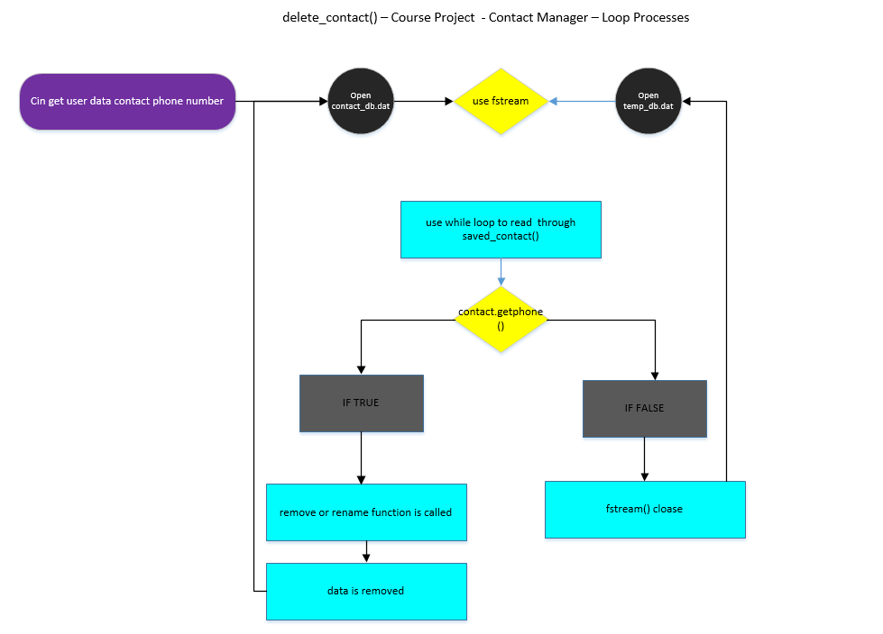

**Diagram 1:2**

**Edit Contact Function:**

Pseudocode:

1. The edit function will clear the screen and return the cursor to the left of the screen.
2. Display user message to enter the phone number
3. Accept user input for the phone number
4. Declare Boolean variable set to false.
5. Declare number variable
6. use fstream to open the file stream contactDB text file.
7. Use a while loop to read through the fstream file and loop through the contact data in the text file using a character pointer.
8. Calls to class objects to loop through arrays
9. Used condition to declare a while loop false
10. if false instantiate if statement call gets phone function.
11. Call show contact function
12. Display user message
13. Call create con function Loop through object arrays
14. Find position of contact number
15. Set the position of the pointer in the output sequence
16. Set the pointer to write to the text file
17. Show user message
18. Change found to true to end statement
19. If while loop is true fstream is to close
20. If found equals false display user message no contact message was found. 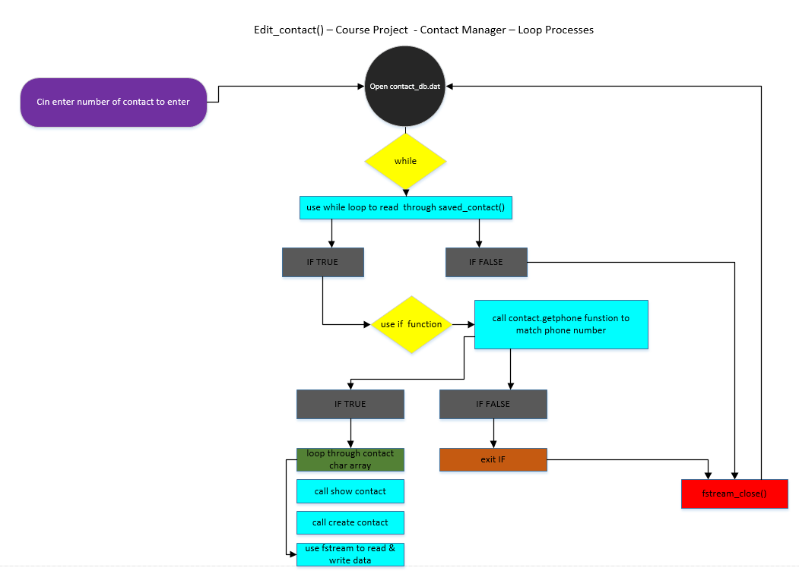

**Diagram 1:3**

**Display Contact Function:**

**Pseudocode:**

1. Display contest function which will show individual contact.
2. Invoke a Boolean found variable
3. An integer character variable
4. Set found variable to false
5. call file stream to open the contactDB file ios::in only.
6. Use while loop to open app fstream read through loop of matching contact array using the pointer char*
7. As long as statement is true invoke the if statement.
8. If statement will call the getphone method
9. If phone number matches user input or Loop through the forget phone function matching user data in the array
10. Clear screen
11. Call Show contact function
12. Display user contact info
13. I found equals true
14. File stream closes
15. Use if statement to set found two false
16. Show user output message sorry no contest
17. Re-establish get Char function to get reference to the pointer system method.

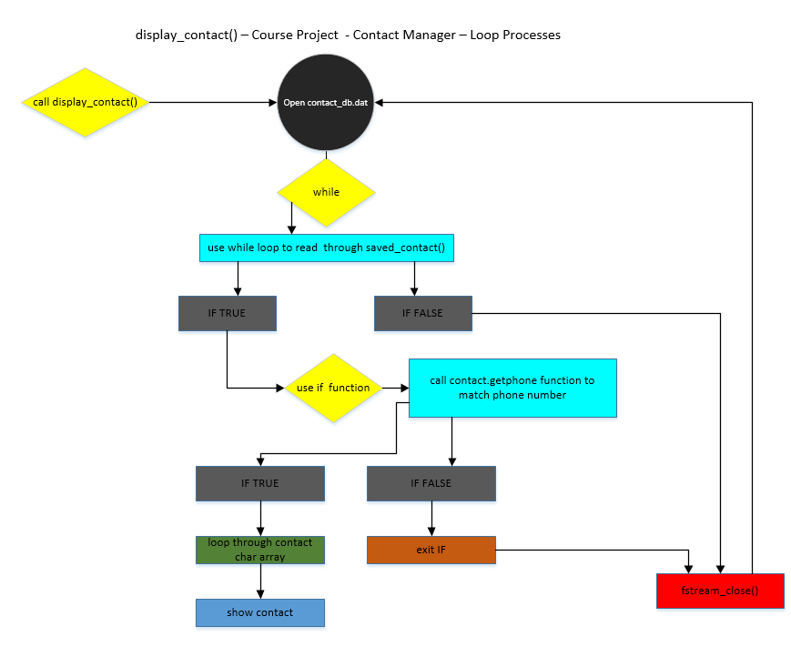

**Diagram 1:4**

This is an outline of the CMS Contact manger array, search and sort structures & pseudo code.